**Outreach GDS Toolkit Readme**

# Introduction

The Outreach gov.uk toolkit allows a base customisation of the styling and certain look and feel aspects of the Outreach forms that adheres to the GDS guidelines (at time of writing as of October 2014).

It is a package containing a GDS Theme, CSS, Javascript files and an outreach code module, which are added to any Outreach installation.

It provides a quick and simple way to get GDS styling in Outreach without the need for bespoke development.

# Installing the GDS toolkit

## Pre-requisites

Before installing the GDS Toolkit, you will need to have a copy of *Outreach Server* and *Outreach e-Form Designer* installed on your server, as well as all associated pre-requisites. For further details, please see the *Outreach Server Installation and Configuration Guide*.

## Installation

1. Copy all files from the *Static* directory of the GDS Toolkit release into your Outreach *Static* directory (this should be located at *C:\Program Files (x86)\OfficeForms\Server\Template\VirtualForm\Static*).
2. Copy *OutreachGDSCustomStrings.htm* from the *Custom* directory of the GDS Toolkit release into your Outreach *Custom* directory (this should be located at *C:\Program Files (x86)\OfficeForms\Server\Template\VirtualForm\Custom*).
3. Copy *OutreachGDS_repo.ofcodemodule* from the *OFServerForms* directory of the GDS Toolkit release into your Outreach *Active Forms* directory (this should be located at *C:\OFServerForms*).
4. Copy *OutreachGDS.theme.xml* from the *Themes* directory of the GDS Toolkit release into your Outreach *Themes* directory (this should be located at *C:\OFServerWorking\Themes*).
5. Start (or restart) your Outreach server:

* Press Windows Key + R to open the *Run* prompt. Type in *services.msc* and click OK.
* In the *Services* window, scroll down until you find the *OfficeForms Server* service.
* Click the *OfficeForms Server* service and select either *Start* or *Restart* on the left sidebar.

# GDS toolkit features

## Buttons

GDS Outreach forms can have three button types:

1. Primary call-to-action



1. Secondary actions



1. Secondary toolbar & table actions



By default, a form configured to use the GDS toolkit will have a *Continue* button (equivalent to the *Next* button in default Outreach forms), *Exit* button and *Back* button (if there is a previous section to go back to) on the bottom toolbar.

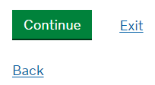

## Help Text

In order to utilise GDS-style help, a specific prefix needs to be added to the start of the help text. The available prefixes are as follows:

* **Micro text** *(__micro:*) – Available for both standard captions and caption over field.

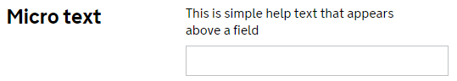

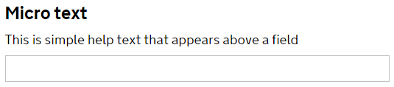

* **Help text** (*__text:*) – Available for both standard captions and caption over field.

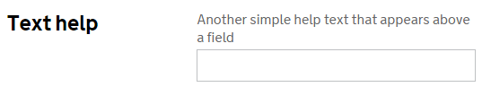

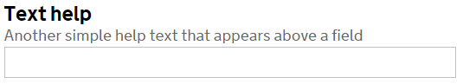

* **Indented micro text** (__*indmicro:*) – Available only for captions over field.

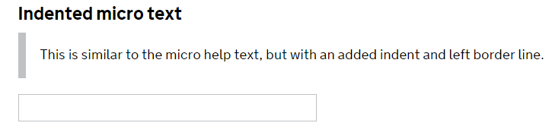

* **Captioned dropdown** (*__drop:*) – Available only for captions over field.

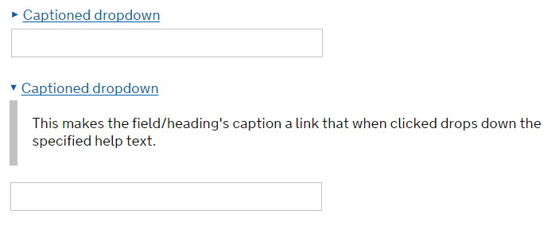

* **Help dropdown** (*__help:*) – Available only for captions over field.

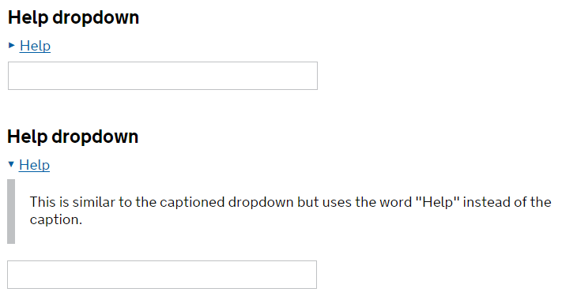

* **Guidance text** (*__guidance:*) – Available only for captions over field.

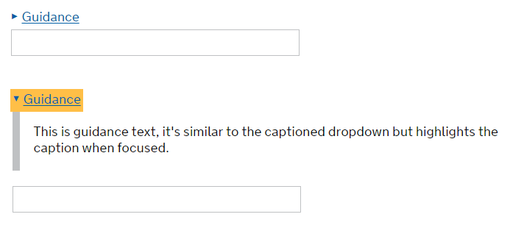

## Indented Headings

In order to indent content, add a heading that ends with the suffix __ind above all the fields and captions you wish to indent.

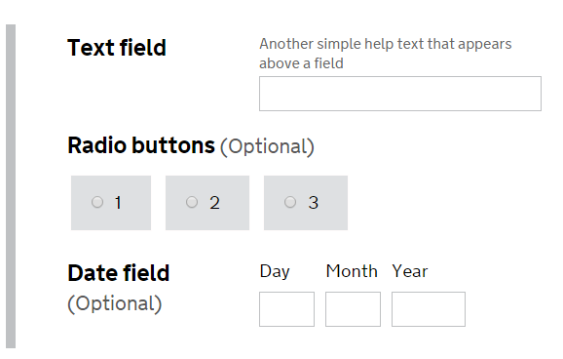

## Summary

The summary feature auto-generates a structured summary of the entire form’s fields and tables.

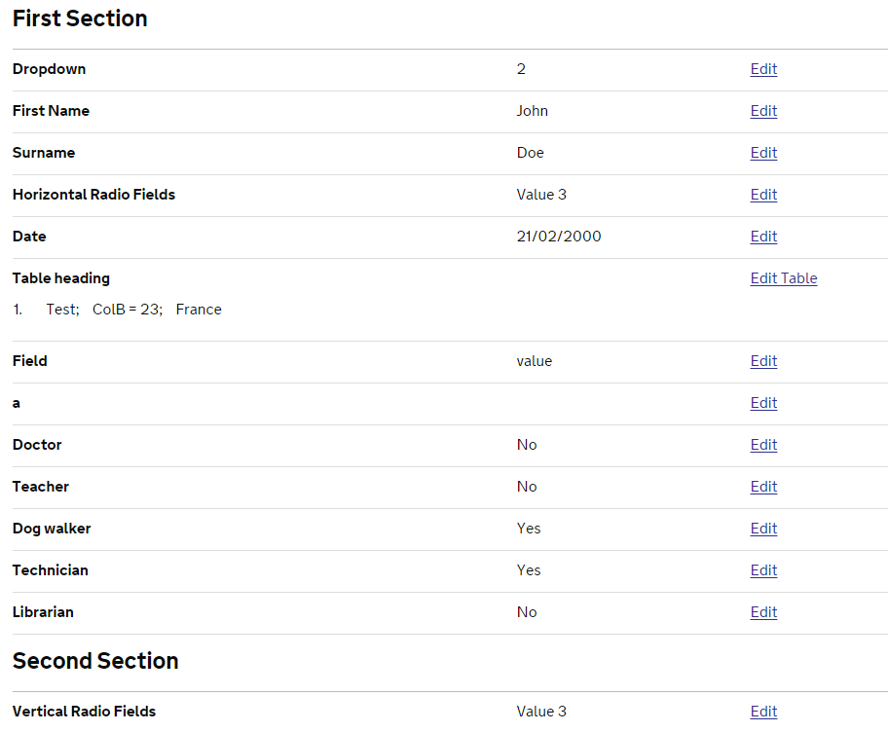

### Summary customisation

By default, the *Summary* feature will display all fields and table columns that are both enabled and visible. In some cases, you may wish to exclude some of these enabled and visible fields or columns from the summary. In order to do this, simply change the relevant item’s name to end with the suffix *__nosumm*.

Similarly, if you have a hidden or disabled field or column that you wish to display in the summary, change the relevant item’s name to end with the suffix *__showsumm*.